**Title:** Nuisance species compromise the carbon sequestration potential in an Eastern US temperate deciduous forest

**Authors :**

Luca L. Morreale1,2*

Rachel Hoffman

Krystal Bagnaschi

Iris Kennedy

Erin MacMonigle

Caroline Troy

Cameron Dow

Valentine Herrmann1 ( Orcid ID : 0000-0002-4519-481X)

Jen Jordan

Lukas Magee

David Mitre

Christopher Pate

Jess Shue

William McShea

Kristina J. Anderson-Teixeira1,2 ( Orcid ID : 0000-0001-8461-9713)

**Author Affiliations:**

1. Conservation Ecology Center; Smithsonian’s National Zoo & Conservation Biology Institute; Front Royal, Virginia 22630, USA
2. Forest Global Earth Observatory, Smithsonian Tropical Research Institute, Apartado Postal 0843-03092, Panama City, Panama

*corresponding author: [MorrealeLL@si.edu](mailto:MorrealeLL@si.edu);

**Running head:**

for submission to Anthromes joint special collection in New Phytologist/ Plants, People, Planet: <https://www.newphytologist.org/news/view/332>

*(Word limit: 6,500 words)*

# Summary

*Summary format for New Phytologist must be under 200 words and should be organized using four bullet points to indicate: (1) the research conducted, including the rationale, (2) methods, (3) key results, and (4) the main conclusion, including the key points of discussion*

Temperate deciduous forests play a critical role in the global carbon (C) cycle, accounting for a substantial portion of the global forest C sink. The dominant view imbued in Earth System Models is that, at least within the eastern United States, the biome is likely to remain a C sink throughout the 21st century. However, these models do not incorporate nuisance species – *i.e.*, species whose local abundance has increased as a result of human activities and that are causing ecological harm. Nuisance species are known to increase tree mortality (*e.g.*, non-endemic pests and pathogens) and decrease recruitment (*e.g.*, deer and non-endemic plants) throughout the temperate deciduous biome, yet the net effect on current and future C cycling is unknown. Here, we use 15 years of detailed census data from a large (25.6 ha) forest dynamics plot in a Mid-Atlantic temperate forest, including a 4-ha deer exclosure, to understand how nuisance species are affecting C cycling. We show increased biomass mortality, a net reduction in aboveground C storage, and decreased abundance of canopy tree species in the understory. Under current trends this forest will continue to lose C sequestration capacity, indicating that the C sequestration of temperate deciduous forests is likely overestimated.

**Keywords**:

*New Phytologist allows 5-8 keywords. Short phrases are acceptable*

# 1 Introduction

The temperate forest biome plays a critical role in the global carbon cycle, accounting for almost half of the net global forest carbon (C) sink (Harris *et al.*, 2021), with deciduous forests representing a substantial portion of this, sequestering >300 Tg C yr-1 (Pugh *et al.*, 2019). Although currently a C sink, the future of the biome remains uncertain. The dominant view imbued in Earth System Models is that, at least within the eastern US, the biome is likely to remain a C sink for the remainder of the 21st century (Finzi *et al.*, 2020; Wu *et al.*, 2023), albeit with declining CO2 sequestration capacity (Ahlström *et al.*, 2012). Yet, global C models predict a wide range of future trajectories of CO2 sequestration (Ahlström *et al.*, 2012; Arora *et al.*, 2020), and current global C models do not represent some influential mechanisms (e.g., Fatichi *et al.*, 2014; Clark *et al.*, 2021). One mechanism that is not represented in global C models is the impact of nuisance species – i.e., endemic or non-endemic species that, as a result of human influence, have much greater abundance in an ecosystem than they did historically, resulting in undesirable ecological consequences (**refs?**). Similarly, the impact of nuisance species on forest carbon budgets is not considered in machine learning/niche models that seek to project future forest distribution and carbon stocks (**?** Wu *et al.*, 2023), nor in carbon offset projects (**???** **refs?**). This is problematic in that nuisance species – including nonindigenous insect pests and pathogens, nonindigenous plants, and over-abundant herbivores – are dramatically impacting carbon cycling in temperate deciduous forests around the world, as described below. “Tree mortality is one of the largest uncertainities in projections of future forest dynamics” (Bugmann et al. 2019)

Nuisance pests and pathogens can have a protracted and enduring impact on forests, often modifying forest productivity, nutrient cycling, successional trajectories and geomorphic processes (Lovett et al. 2016, Fischer et al. 2013, Herms and McCullough 2014, Fei et al. 2014). The presence of nonindigenous forest insects and diseases, which have been historically introduced to new ecosystems through intercontinental trade, will continue to proliferate with increased globalization and human movement (Fischer et al. 2013, Aukema et al. 2010, Brockerhoff et al. 2006). Many of the prominent pests and pathogens in temperate deciduous forests have devastating effects on canopy composition and structure. Once abundant in temperate deciduous forests throughout North America, the American Chestnut (*Castanea dentata*) and the Ash genera (*Fraxinus spp.*) have been decimated by pests and pathogens, with stand-clearing disturbances occuring within a few years after initial infestation (Anderson 2020, Klooster et al. 2013, Need a source for Ash abundance and length of time between infestation and mortality for Chestnuts). These previously dominant overstorey species are now confined to the understory as non-reproductive seeds and saplings (Elliot and Swank 2008, Anagnostakis 1987, Need a source for Ash). In other species, such as the Eastern Hemlock (*Tsuga canadensis*), the existence of pests and pathogens induces close to total population mortality, with considerable risk of regional extirpation (Ellison et al. 2018). The loss of mature canopy species to nuisance species contributes to global change driven biomass losses, with biomass losses due to pest and pathogens likely comparable to those attributed to fire and forest removal (Fei et al. 2013) Since many pests and pathogens do not currently occupy the full extent of their host species range, a significant portion of the remaining forest canopy is susceptible to future invasion from nuisance species, further increasing potentials for biomass loss and altered carbon cycle dynamics (Fei et al. 2013)

Non-endemic pests and pathogens have been important driver of mortality (Anderson-Teixeira *et al.*, 2021). These can reduce C and need to be considered in future climate change projections.

Fei *et al.* (2019)

Non-endemic pests and pathogens facilitate invasion of non-endemic plants (Guo *et al.*, 2023 and refs therein).

White-tailed deer (*Odocoileus virginianus*) are a nuisance species prevalent in eastern deciduous forests.*Start with a stronger sentence about the impact of deer on herbivory - Ex. White-tailed deer are the dominant herbivore in eastern deciduous forests (Reference)* Their populations have dramatically increased in the past 50 years (McShea et al. 1997). *Find a reference with a specific number of increase in deer populations* due in large part to global change drivers. (Found in McGarvey et al. 2013 – Brown et al. 2000, Côté et al. 2004, Rooney 2001). White-tailed deer preferentially browse on woody plant species in their earliest life stages (McGarvey et al. 2013), with overabundant herbivory reduce seedling and sapling survival, growth and density (Found in McGarvey et al. 2013 – Dzieciolowski 1980, Gill and Beardall 2001, Healy 1997, Konig 1976, Putman et al. 1989). Chronic overabundance has been shown to reduce understory diversity and decrease the abundance of traditionally dominant species (*NEW CITATION*). Due to climate change and human activity, many non-endemic plant species are being introduced or number in forest ecosystems (Reference). Deer find many of these species, including pawpaw (Asimina triloba), to be unpalatable (Found in McGarvey 2013 – Asnani 2006), and do not consume them at the same rates relative to their native counterparts (Reference), enabling them to form dense stands in forest understories (Found in Knauer et al. 2023 – Horsley and Marquis 1983; Stromayer and Warren 1997; Royo and Carson 2006). This lack of browsing pressure, coupled with characteristics such as fast growth rate and greater adaptability to altered conditions precipitated by climate change, allow nuisance plant species to outcompete other species in the understory (Reference). The interaction of these nuisance species on the landscape contributes to a recruitment failure in forests, [*Where individuals from certain tree species do not enter the mature population - Do we need to define recruitment failure, or is that considered common knowledge? If so, reference*). The extent of the consequences derived from recruitment failure on species composition and forest structure is often not apparent for years (McGarvey et al. 2013)

* white-tailed deer (*Odocoileus virginianus* ) is important endemic nuisance species, over-abundant because of human influence

McGarvey *et al.* (2013) Holm *et al.* (2013) Knauer *et al.* (2023)

The capacity to regenerate following disturbances, including ongoing gap formation through mortality of canopy trees, critically influences long-term forest dynamics. Regeneration depends first upon seed production and then upon seedling recruitment, survival, and growth into trees. When any one of these steps fails, the stage is set for disturbance to push forest ecosystems over a tipping point, whereby there is little chance that a forest will recover to it’s pre-disturbance state in the foreseeable future (**refs?**). Global change pressures can set the stage for such critical transitions by gradually shifting baseline conditions, making post-disturbance recovery unlikely despite the persistence of mature trees (Anderson-Teixeira *et al.*, 2013; McDowell *et al.*, 2020; **refs?**). In the mid-Atlantic region of eastern North America, forests face a severe “regeneration debt”, meaning that there are insufficient juveniles of current canopy tree species to replace the mature cohort when they eventually die (Miller & McGill, 2019; Miller *et al.*, 2023). Low juvenile abundance in the region is driven by a combination of over-abundant deer, competition with non-endemic species, and possibly climate change (Russell *et al.*, 2017; Miller & McGill, 2019; Gorchov *et al.*, 2021; Miller *et al.*, 2023). Deer are the biggest problem (Gorchov *et al.*, 2021). The juveniles that are present tend to represent a different, more mesophytic set of species (*Acer spp.*, *Fagus grandifolia*) than currently dominate much of the region (*Quercus spp.*, *Carya spp.*, Miller & McGill (2019); Nowacki & Abrams (2015)]–a dynamic driven by fire suppression and mesophication (**refs?**).

Here, we use 15 years of detailed census data from a large forest dynamics plot including a 4-ha deer exclosure to test the following hypotheses: (1) ) Aboveground C stocks in living biomass have declined since the initial census (-∆AGB) (2) canopy tree mortality and associated woody biomass loss are increasing, in large part due to nonindigenous nuisance species (3) Recruitment and woody growth have not kept pace with tree mortality, suggesting that future mortality will result in substantial net biomass loss and sustained decrease in the C storage potential of this ecosystem.

# 2 Materials and Methods

## 2.1 Site Description

The study was conducted in the 25.6-hectare Large Forest Dynamics plot at the National Zoo and Conservation Biology Institute in Front Royal, Virginia (38 53’36.6“N, 78 08’43.4 “W). The plot, which is located in the central Appalachian Mountains adjacent to Shenandoah National Park, is composed of mature secondary eastern deciduous forest. Situated in the Appalachian Oak forest region, the canopy is dominated by tulip poplar (*Liriodendron tulipifera*), oak (*Quercus spp.*), and hickory (*Carya spp.*) and the understory is primarily composed of spicebush (*Lindera benzoin*), paw-paw (*Asimina triloba*), American hornbeam (*Carpinus caroliniana*) and witch hazel (*Hamamelis virginiana*) (SCBI site description). The land-use history of the site is varied, including periods of agricultural development and intensive logging, with dendrological data estimating canopy tree establishment around 1900 (SI archives, Bourg et al. 2013). Natural disturbances at the plot consist of wind and infrequent ice storms (Anderson-Teixiera 2015). The plot, which includes a four-hectare deer exclosure that has decreased the presence of deer since 1990, is divided into 640 quadrats, each measuring 20 x 20 meters. It is one of 78 sites in the Forest Global Earth Observatory (ForestGEO), a global network of forest dynamic plots that promotes comparative forest ecology studies around the world.

* Add information about the history of pests and pathogens at this site and at similar forests

In addition to our consideration of the plot as a whole, we give special consideration to three portions of the plot, all upland forest (i.e., excluding low-lying areas around streams): (1) low deer, low non-endemic insects & pathogens - 4 ha portion of upland forest in the SE quarter of the plot, fenced in YEAR and maintained with only occasional deer presence for the past ## years and with relatively low abundance of canopy species affected by non-endemic pests and pathogens; (2) high deer, low non-endemic insects & pathogens # ha of upland forest outside the deer exclosure with relatively low abundance of canopy species affected by non-endemic pests and pathogens; (3) high deer, high non-endemic insects & pathogens - a # ha section of upland forest outside the deer exclosure with relatively high abundance of canopy species affected by non-endemic pests and pathogens. These areas were delineated as follows. Upland forest was defined according to topographic wetness index, originally calculated for the SCBI plot in McGregor *et al.* (2021). Vulnerability to non-endemic insects & pathogens was defined based on the abundance of canopy species affected by non-endemic pests and pathogens at the time of plot establishment (2008).

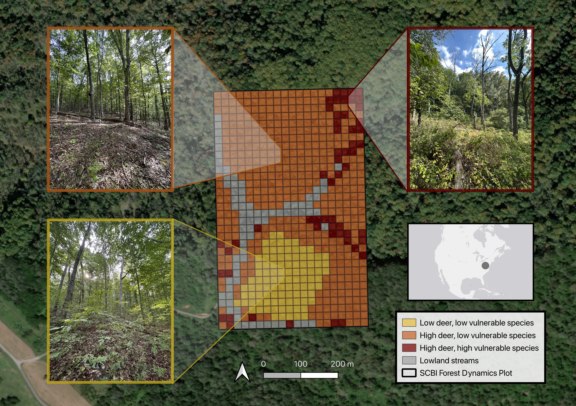

**Figure 1. Photos within the SCBI ForestGEO plot: (a) low deer, low non-endemic insects & pathogens, (b) high deer, low non-endemic insects & pathogens, (c) high deer, high non-endemic insects & pathogens**  *(add a map of the plot)* All photos taken September 2023 by K. Anderson-Teixeira.

## 2.2 Data collection

A number of field surveys are regularly conducted at the site, two of which are included in our analysis. As part of the ForestGEO network, the plot undergoes a comprehensive woody plant inventory every five years, according to the protocol outlined in Condit (1998). This inventory, hereby referred to as the census, includes all stems greater than 1 centimeter in diameter breast height (1.3 meters; dbh). The census records information regarding the dbh, species, status and location of each stem included in the survey. Each invidual is assigned an identifying number for sequential data collection in subsequent censuses and outfitted with a metal tag in the field. In multi-stemmed individuals, each additional stem that surpasses the 1 cm dbh threshold receives a stem number and associated tag. Location is recorded on a digitized map of the plot on the ESRI ArcGIS FieldMaps application (*citation*). Established in 2008, there have been four censuses at the site, comprising 15 years of detailed forest dynamics data. In addition to the ForestGEO census, an annual mortality survey is conducted on the site. Through assessing individual tree health, this study illustrates trends in forest mortality and identifies factors that are associated with death. Data is collected on the current status, canopy position, percentage of crown living and intact, and visible indicators of poor tree health, such as physical damage, potential pathogens and insect infestation.

*In response to the presence of Emerald Ashborer, a mortality survey was initiated, then improved in year [X].

To improve the quality of the data, GitHub Actions continuous integration was implemented for quality control (Kim et al., 2022). Data from the previous census was used to populate the Field Maps app, and fields were created to input data. There were checks built into the app to help catch errors, for example the DBH field would flag a suspiciously high number and would not allow the form to be submitted if it was blank. To use the app in the field the census crew downloaded offline areas of where they were working and synced them to an online map after collecting data. Next the data was downloaded from ArcGIS online and pushed to GitHub, where it triggered a GitHub Action running data quality assurance and control (QA/QC) scripts. The scripts were written in R and checked the data for errors such as “suspicious positive growth.” After going through the QA/QC process, a csv of errors and warnings with the associated stem were output which could then be corrected in the field.

## 2.3 Analyses

* We

# 3 Results

For the first time since the establishment of the SCBI ForestGEO site, whole-plot aboveground C stocks decreased (Figure 2). From 2018 to 2023, whole-plot C stocks have decreased from **“X to X”** Mg C/ha. Both low-nuisance regions show similar decreases in C stocks going from **“X to X”** and **“X to X”** Mg C/ha, respectively. In the high deer high nuisance regions C stocks have decreased for the past two censuses, with a higher magnitude decrease of **“X to X”** Mg C/ha from 2018 to 2023. C stock decrease **is related to/ is explained by** above ground net biomass change. In the first two census intervals, 2008 to 2013 and 2013 to 2018, there were positive C fluxes, but for the 2018 to 2023 interval there was a negative C flux of **VALUE** Mg C/ha/year (Figure 3a).

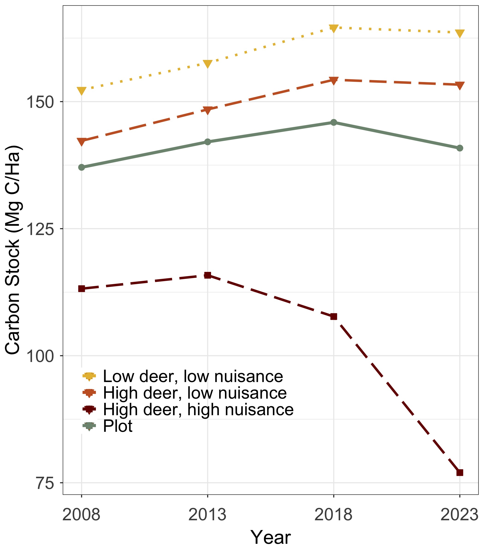

**Figure 2. Aboveground biomass decreased at the site for the first time since establishment. The net decrease at the plot-level was driven by large losses in regions with high vulnerability to nuisance species.**

The trend in net woody production can be explained by its constituent fluxes (Figure 3). Trends in woody mortality show that for the first two census intervals, the whole plot has lost **VALUE** and then **VALUE** Mg C/ha/year, increasing to a loss of **VALUE** Mg C/ha/year for the most recent census interval (Figure 3b). Woody productivity contributes positively to the flux, showing that the whole plot gained **VALUE** Mg C/ha/year in the first interval, **VALUE** Mg C/ha/year in the second, and **VALUE** Mg C/ha/year in the third (Figure 3c). Areas of low deer, low nuisance species were consistently the most productive ending at **VALUE** Mg C/ha/year in the interval 2018 to 2023, and areas of high deer, high nuisance species were the least productive at **VALUE** Mg C/ha/year in the interval 2018 to 2023. Recruitment has consistently added smaller magnitude amounts of carbon with the whole plot gaining **VALUE** Mg C/ha/year (Figure 3d). Recruitment was highest at **VALUE** Mg C/ha/year in areas with high deer and high vulnerable species, and lowest at **VALUE** Mg C/ha/year in areas with high deer and low vulnerable species.

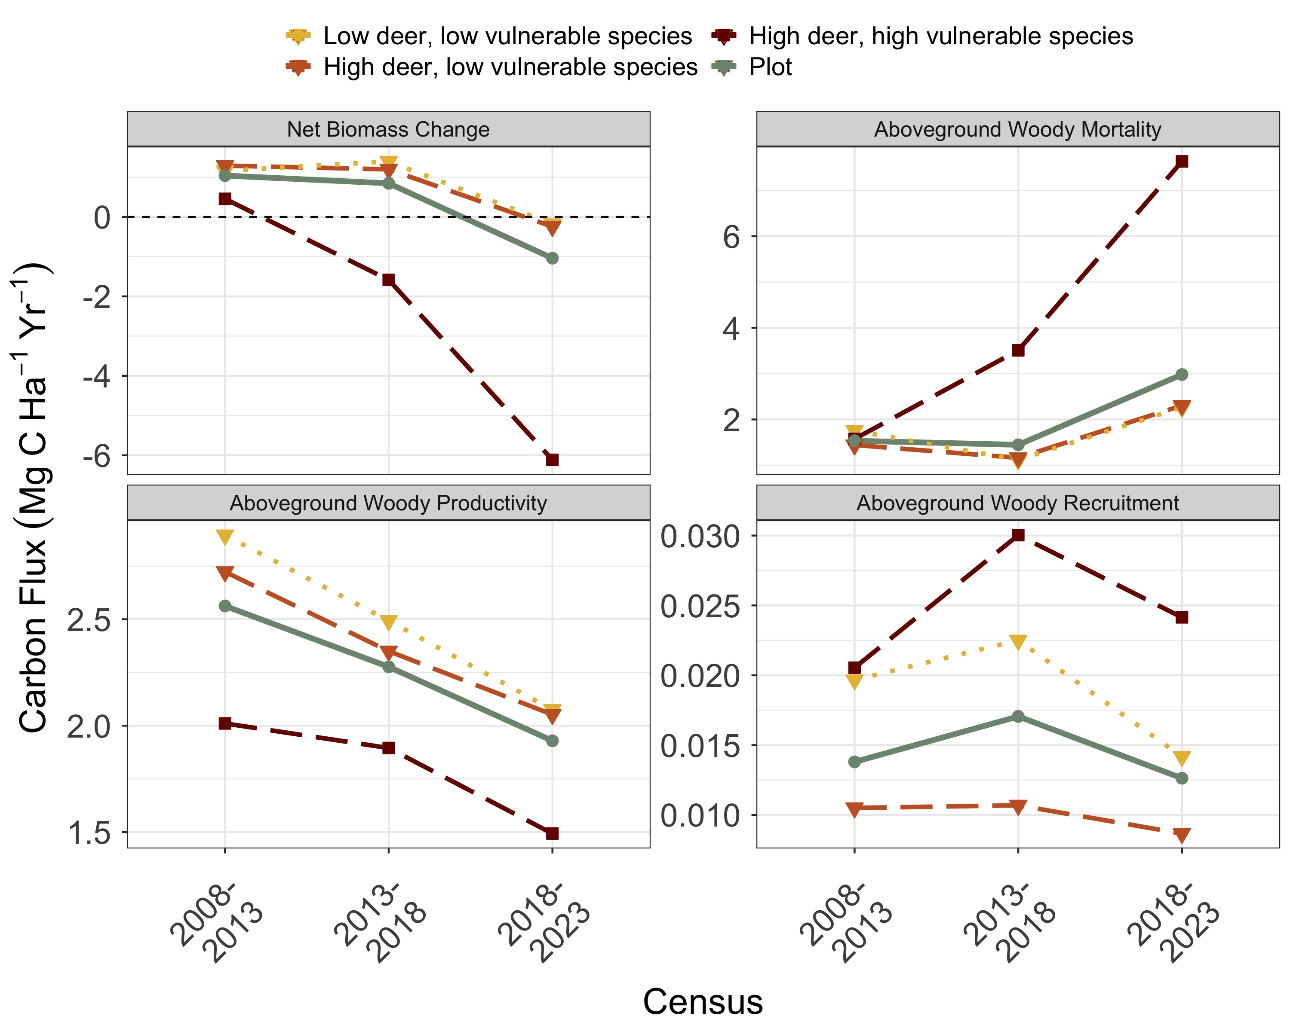

**Figure 3. Fluxes of aboveground woody biomass. Large increases in woody mortality combined with sustained decreases in woody productivity result in decreasing net biomass in the most recent census.**

## 3.1 Species composition of mortality flux

Woody mortality was the primary driver of the negative trend in biomass, and certain species were responsible for higher levels of mortality. Fraxinus americana had the highest aboveground woody mortality rates of any species present on the plot, peaking at **VALUE** Mg C/ha/year lost in *2020* , and **VALUE** Mg C/ha/year lost in 2022 (Figure 4). Quercus velutina contributed the second-highest levels of mortality, losing **VALUE** Mg C/ha/year in 2022. Quercus rubra, Carya species, Quercus prinus, Quercus alba, and Liriodendron tulipifera were all significant contributors as well.

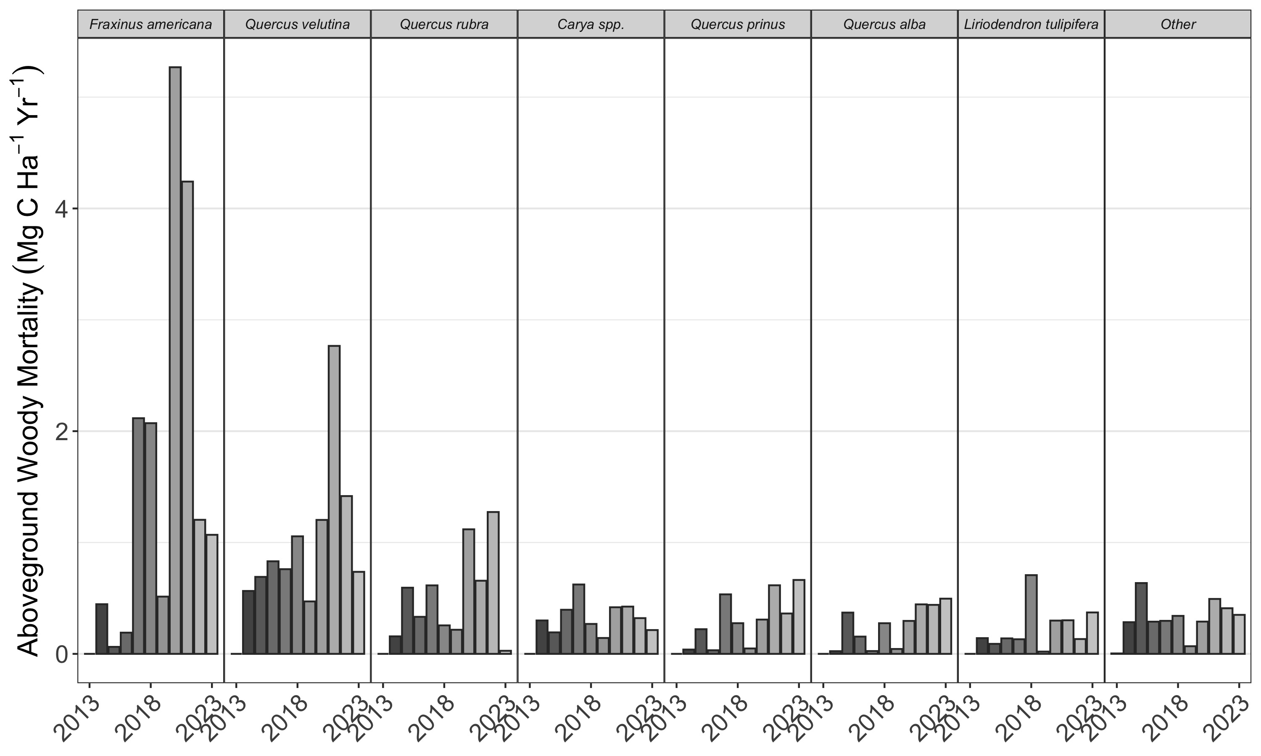

**Figure 4. Annual woody mortality flux by species/genera. We report large increases in mortality of white ash, red oak, and black oak.**

## 3.2 Species composition of recruitment flux

Certain species dominated aboveground woody recruitment, with understory species being recruited at higher rates than canopy species (Figure 5). Out of the canopy species, Carya species showed the highest levels of recruitment with a rate of **VALUE** Mg C/ha/year recruited from 2018 to 2023 (Figure 5a). Acer negundo had the second highest rate of recruitment for canopy species at **VALUE** Mg C/ha/year from 2018 to 2023. Fagus grandifolia, Fraxinus americana, and Ulmus rubra are the other species with the highest recruitment rates. Most canopy species had lower recruitment rates in the 2018 to 2023 census interval than the 2008 to 2013 interval. Lindera benzoin had by far the highest recruitment rate of the understory species at **VALUE** Mg C/ha/year from 2018 to 2023 (Figure 3b). Asimina triloba had the second highest rate of recruitment of the understory species at **VALUE** Mg C/ha/year recruited from 2018 to 2023. Other understory species with high recruitment were Carpinus caroliniana, Hamamelis virginiana, and Celtis occidentalis.

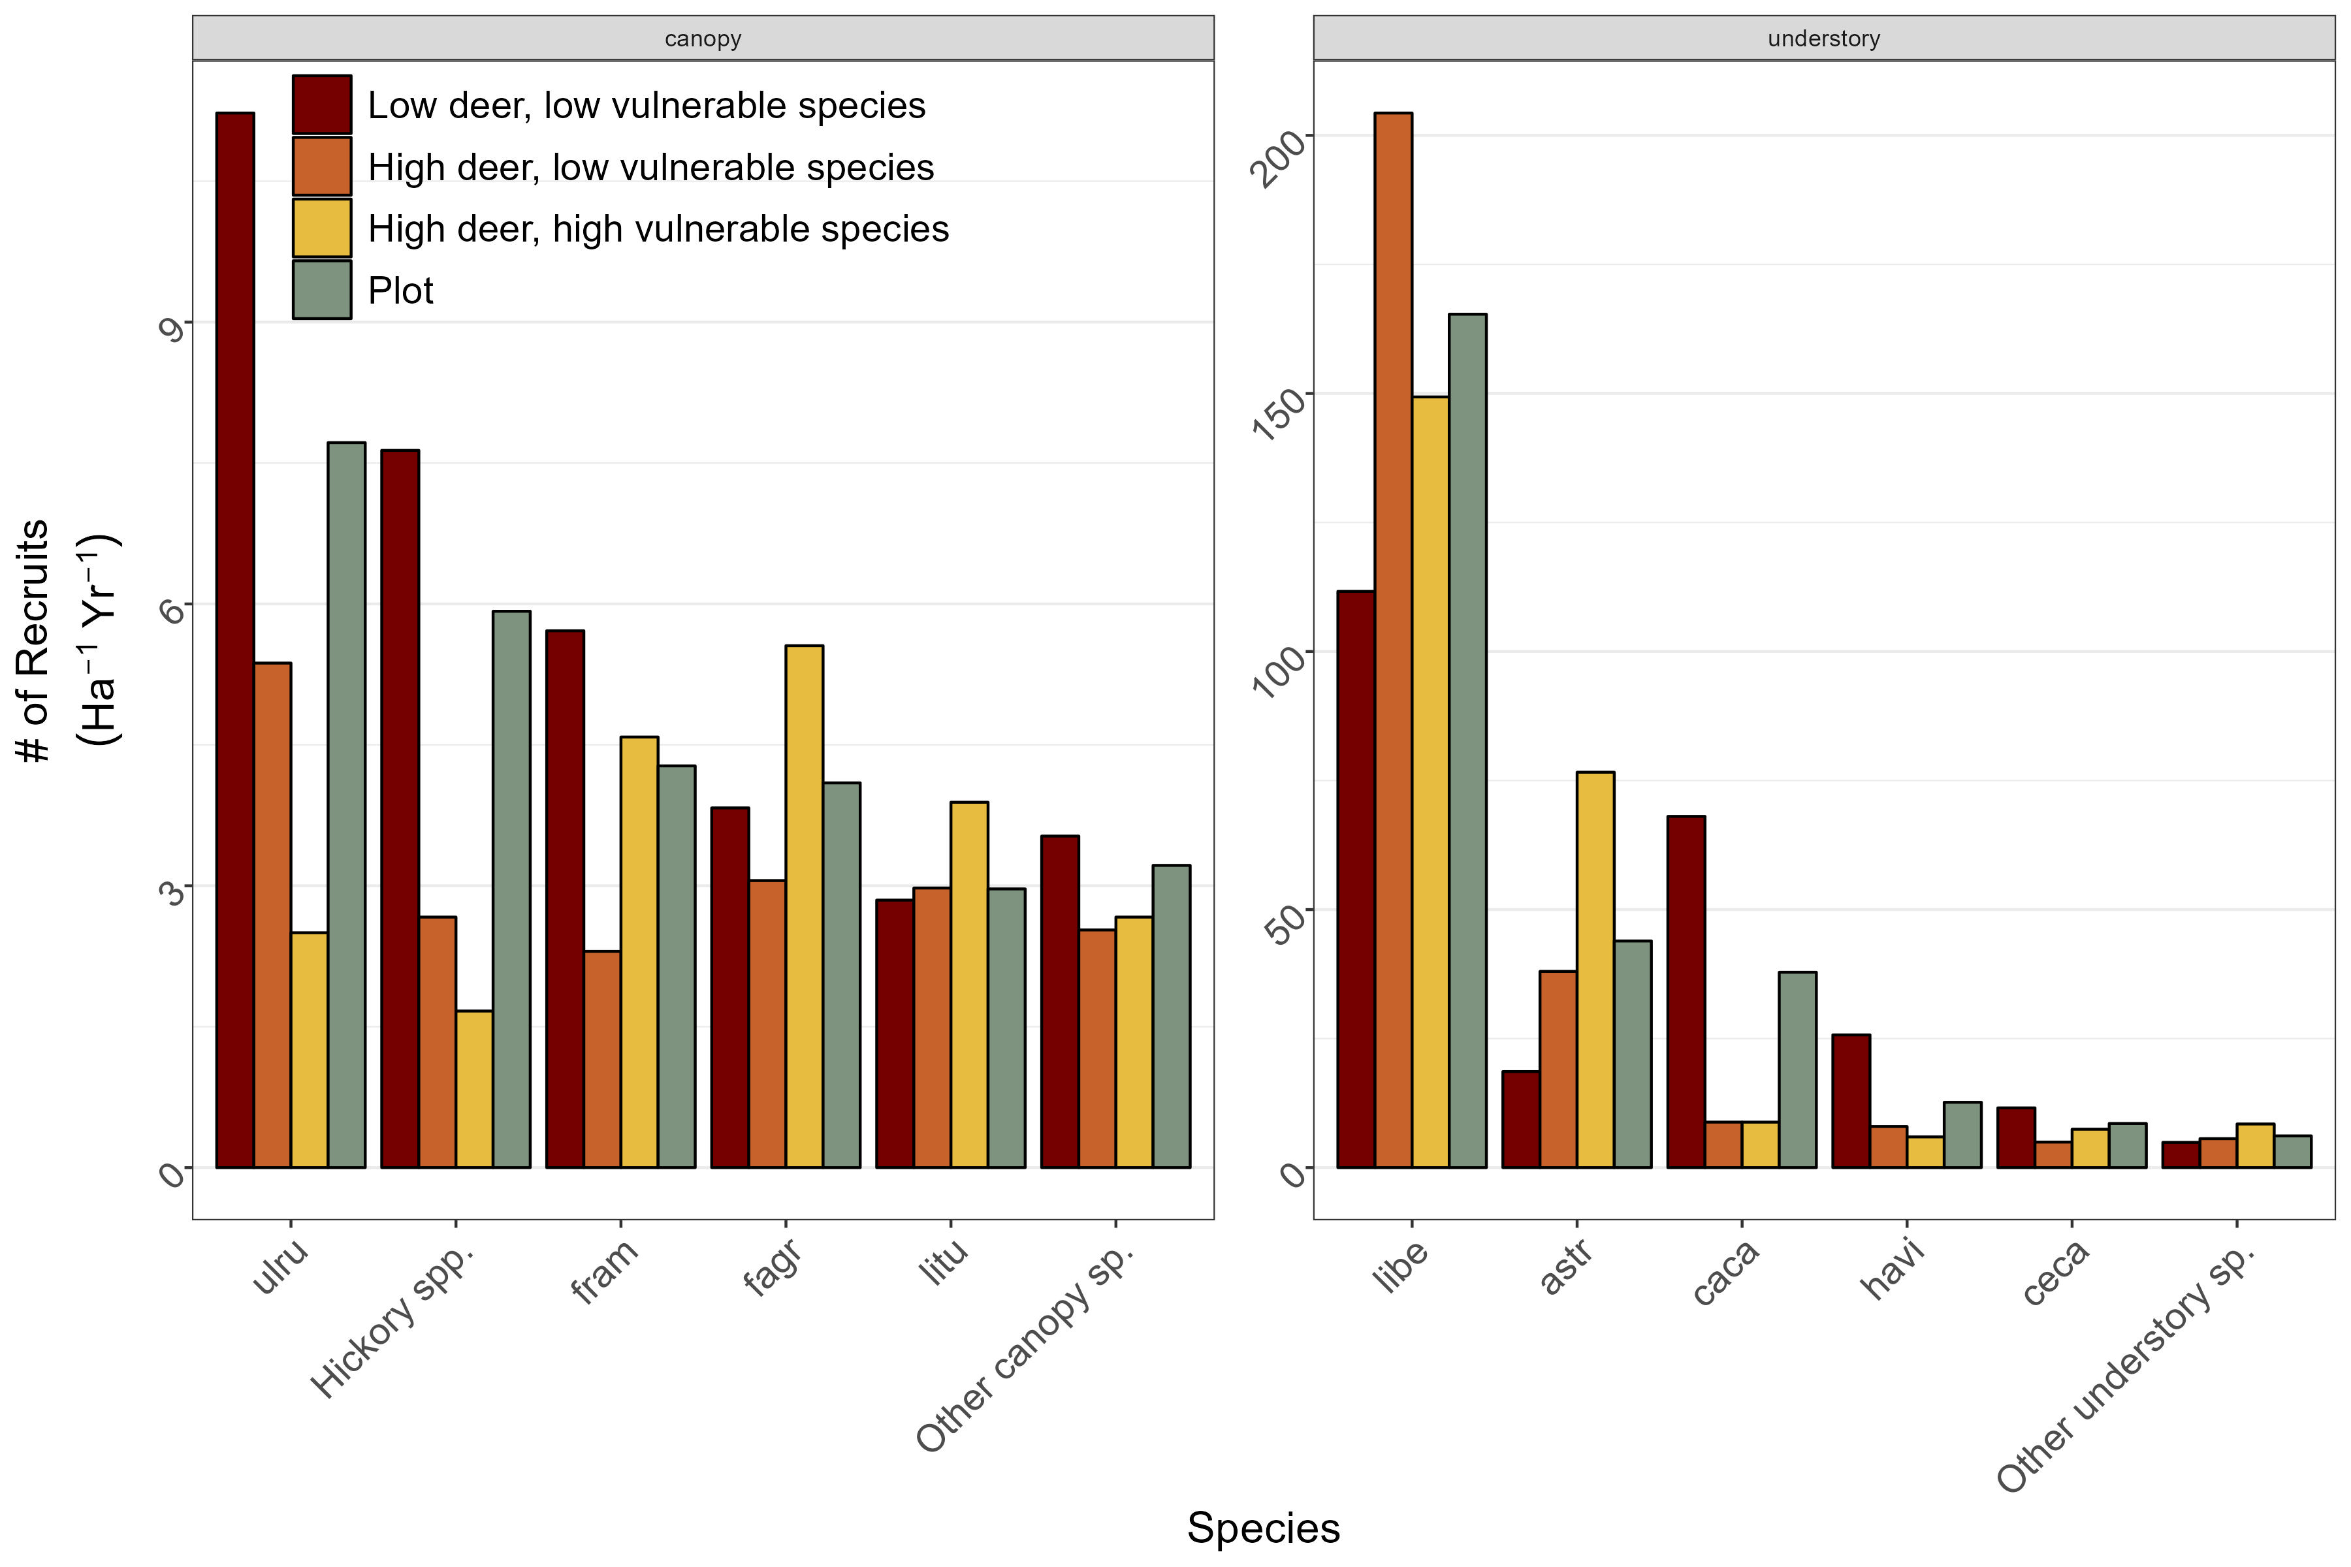

**Figure 5. Annual recruitment of canopy & understory species/genera across all censuses. Recruitment of canopy species is significantly higher within the deer exclosure. Recruitment of understory species is 20x that of canopy species.**

## 3.3 Regeneration & mortality mismatch

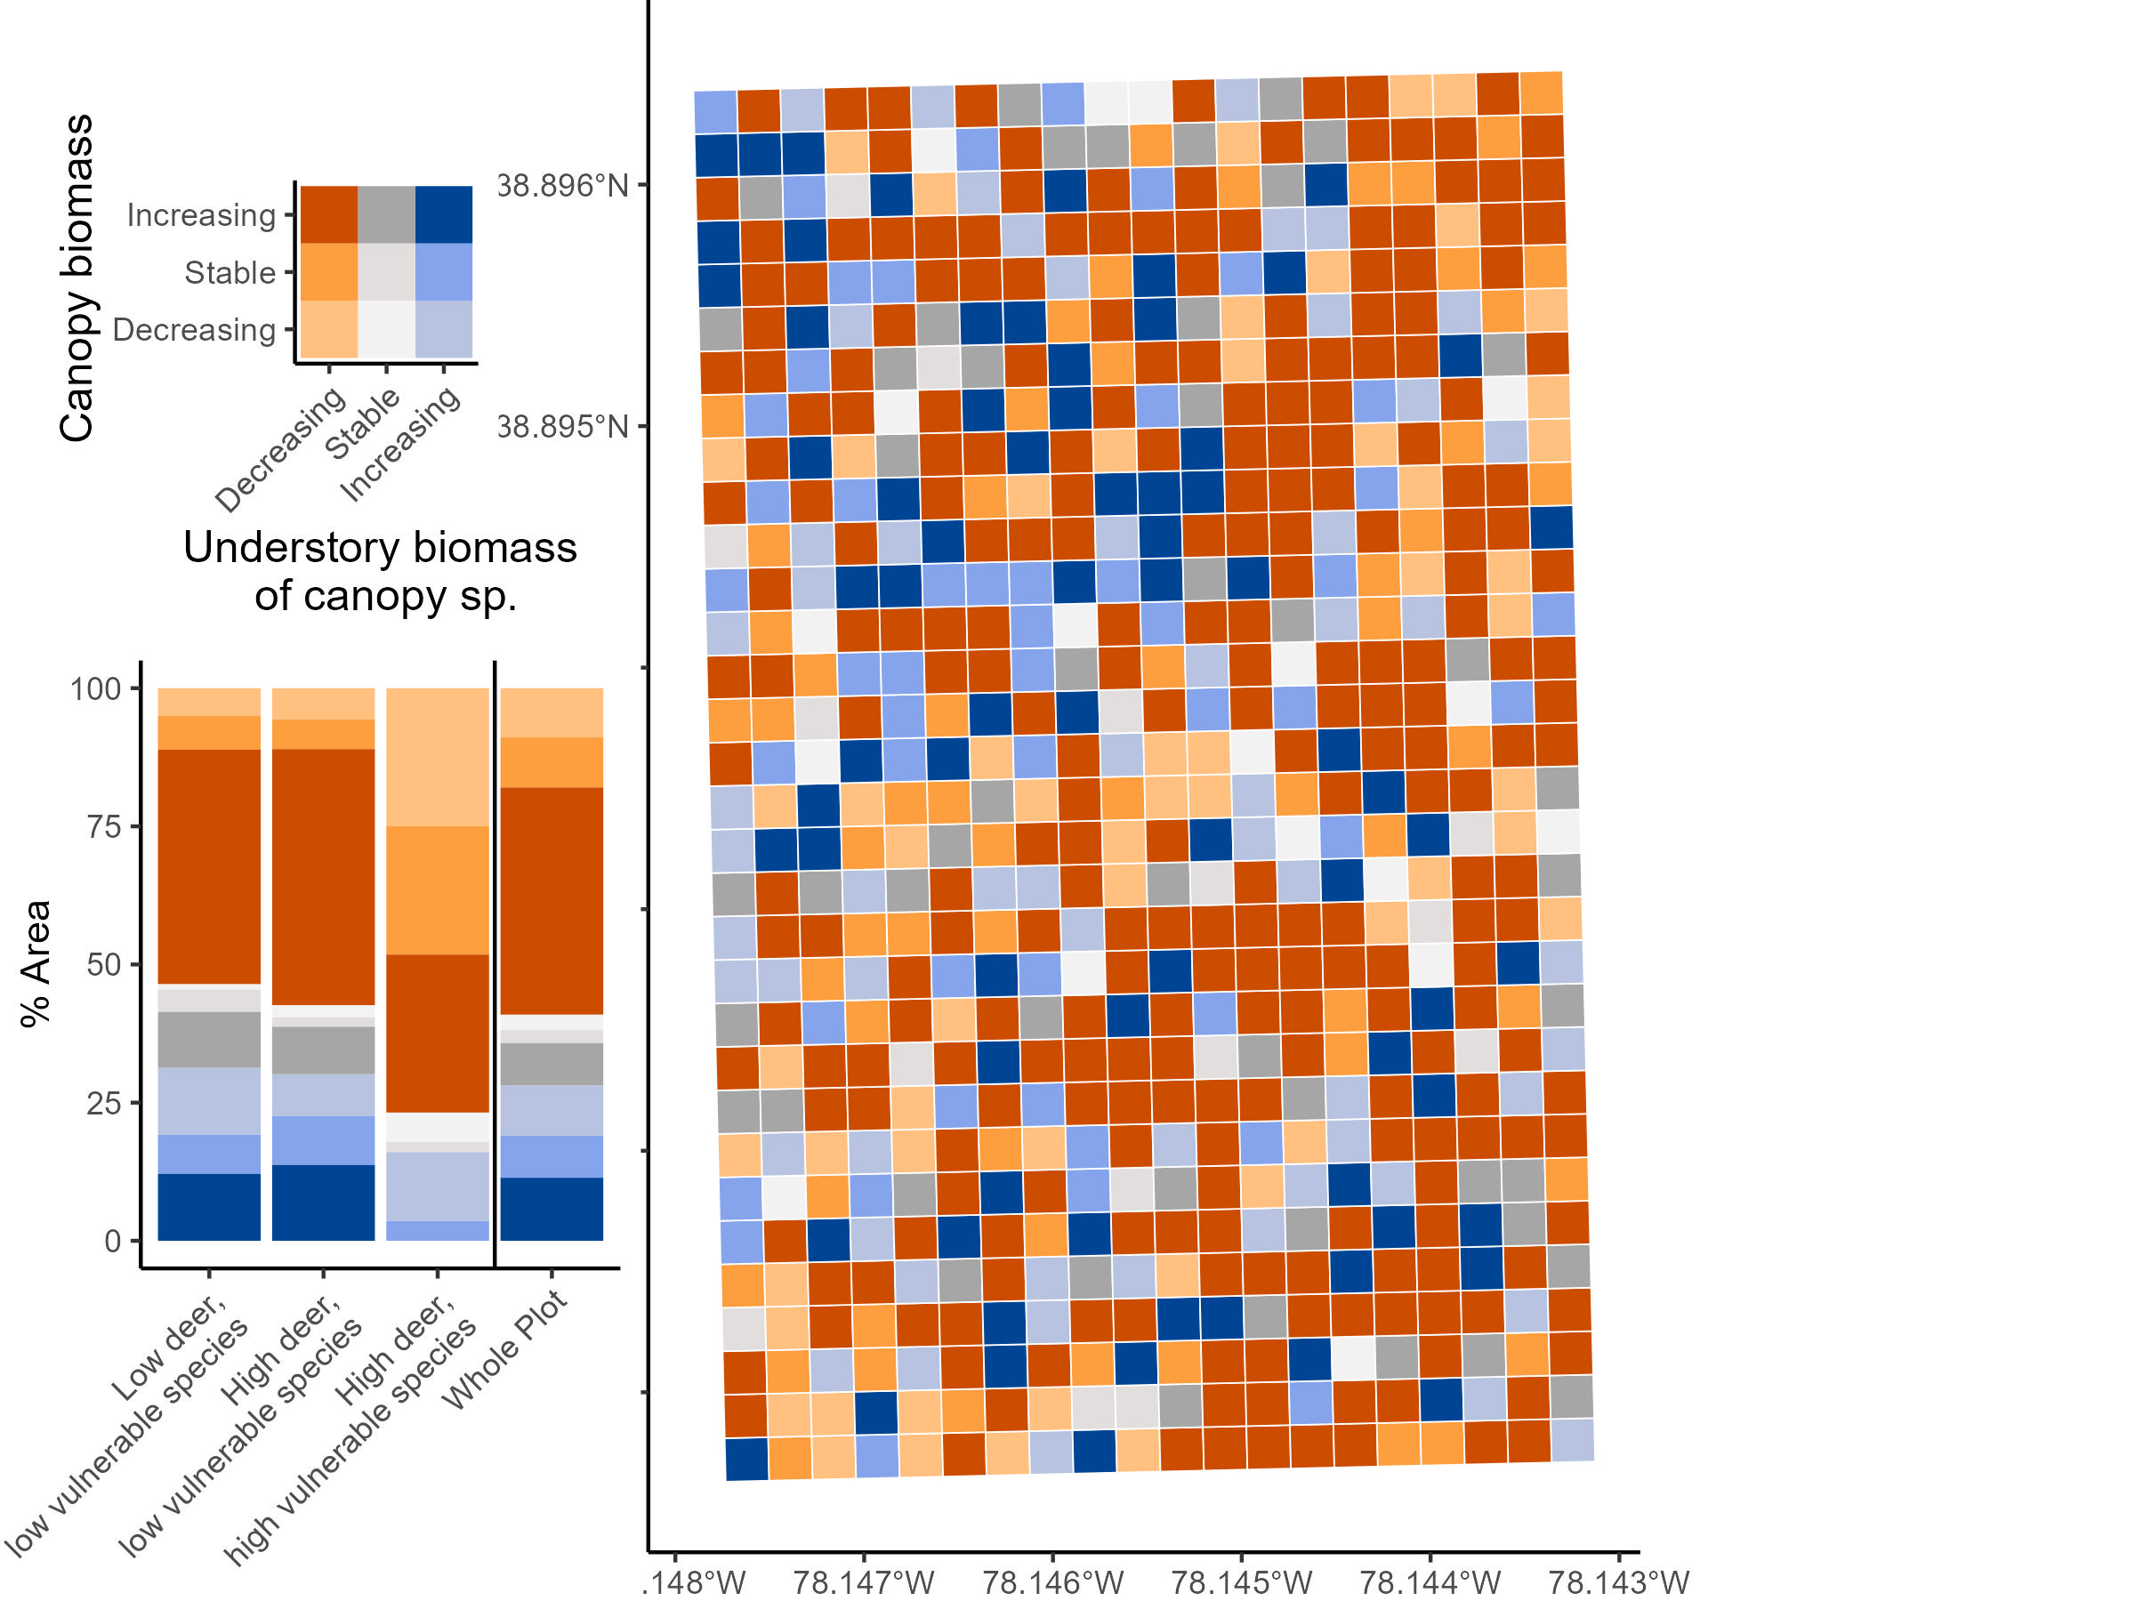

**Figure 6.**

# 4 Discussion

Holtmann *et al.* (2021)

# 5 Conclusions /Future Directions

# Acknowledgements

* Funding: ForestGEO

# Competing Interests

The authors declare no conflict of interest.

# Author Contributions

*[Name of author 1] and [Name of author 2] conceived the ideas and designed methodology; [Name of author 1] and [Name of author 3] collected the data; [Name of author 2] and [Name of author 4] analysed the data; [Name of author 1] and [Name of author 4] led the writing of the manuscript. All authors contributed critically to the drafts and gave final approval for publication.*

# Data availability

# References

**Ahlström A, Schurgers G, Arneth A, Smith B**. **2012**. [Robustness and uncertainty in terrestrial ecosystem carbon response to CMIP5 climate change projections](https://doi.org/10.1088/1748-9326/7/4/044008). *Environmental Research Letters* **7**: 044008.

**Anderson-Teixeira KJ, Herrmann V, Cass WB, Williams AB, Paull SJ, Gonzalez-Akre EB, Helcoski R, Tepley AJ, Bourg NA, Cosma CT, *et al.*** **2021**. [Long-Term Impacts of Invasive Insects and Pathogens on Composition, Biomass, and Diversity of Forests in Virginia’s Blue Ridge Mountains](https://doi.org/10.1007/s10021-020-00503-w). *Ecosystems* **24**: 89–105.

**Anderson-Teixeira KJ, Miller AD, Mohan JE, Hudiburg TW, Duval BD, DeLucia EH**. **2013**. [Altered dynamics of forest recovery under a changing climate](https://doi.org/10.1111/gcb.12194). *Global Change Biology* **19**: 2001–2021.

**Arora VK, Katavouta A, Williams RG, Jones CD, Brovkin V, Friedlingstein P, Schwinger J, Bopp L, Boucher O, Cadule P, *et al.*** **2020**. [Carbon concentration and carbon climate feedbacks in CMIP6 models and their comparison to CMIP5 models](https://doi.org/10.5194/bg-17-4173-2020). *Biogeosciences* **17**: 4173–4222.

**Clark JS, Andrus R, Aubry-Kientz M, Bergeron Y, Bogdziewicz M, Bragg DC, Brockway D, Cleavitt NL, Cohen S, Courbaud B, *et al.*** **2021**. [Continent-wide tree fecundity driven by indirect climate effects](https://doi.org/10.1038/s41467-020-20836-3). *Nature Communications* **12**: 1242.

**Fatichi S, Leuzinger S, Körner C**. **2014**. [Moving beyond photosynthesis: From carbon source to sink-driven vegetation modeling](https://www.jstor.org/stable/newphytologist.201.4.1086). *The New Phytologist* **201**: 1086–1095.

**Fei S, Morin RS, Oswalt CM, Liebhold AM**. **2019**. [Biomass losses resulting from insect and disease invasions in US forests](https://doi.org/10.1073/pnas.1820601116). *Proceedings of the National Academy of Sciences*: 201820601.

**Finzi AC, Giasson M-A, Plotkin AAB, Aber JD, Boose ER, Davidson EA, Dietze MC, Ellison AM, Frey SD, Goldman E, *et al.*** **2020**. [Carbon budget of the Harvard Forest Long-Term Ecological Research site: Pattern, process, and response to global change](https://doi.org/10.1002/ecm.1423). *Ecological Monographs* **90**: e01423.

**Gorchov DL, Blossey B, Averill KM, Dávalos A, Heberling JM, Jenkins MA, Kalisz S, McShea WJ, Morrison JA, Nuzzo V, *et al.*** **2021**. [Differential and interacting impacts of invasive plants and white-tailed deer in eastern U.S. forests](https://doi.org/10.1007/s10530-021-02551-2). *Biological Invasions* **23**: 2711–2727.

**Guo Q, Potter KM, Ren H, Zhang P**. **2023**. [Impacts of Exotic Pests on Forest Ecosystems: An Update](https://doi.org/10.3390/f14030605). *Forests* **14**: 605.

**Harris NL, Gibbs DA, Baccini A, Birdsey RA, Bruin S de, Farina M, Fatoyinbo L, Hansen MC, Herold M, Houghton RA, *et al.*** **2021**. [Global maps of twenty-first century forest carbon fluxes](https://doi.org/10.1038/s41558-020-00976-6). *Nature Climate Change*: 1–7.

**Holm JA, Thompson JR, McShea WJ, Bourg NA**. **2013**. [Interactive effects of chronic deer browsing and canopy gap disturbance on forest successional dynamics](https://doi.org/10.1890/ES13-00223.1). *Ecosphere* **4**: 1–23.

**Holtmann A, Huth A, Pohl F, Rebmann C, Fischer R**. **2021**. [Carbon Sequestration in Mixed Deciduous Forests: The Influence of Tree Size and Species Composition Derived from Model Experiments](https://doi.org/10.3390/f12060726). *Forests* **12**: 726.

**Knauer A, Betras T, Royo AA, Diggins TP, Carson WP**. **2023**. [Understory plant communities fail to recover species diversity after excluding deer for nearly 20 years](https://doi.org/10.1139/cjfr-2022-0234). *Canadian Journal of Forest Research* **53**: 379–390.

**McDowell NG, Allen CD, Anderson-Teixeira K, Aukema BH, Bond-Lamberty B, Chini L, Clark JS, Dietze M, Grossiord C, Hanbury-Brown A, *et al.*** **2020**. [Pervasive shifts in forest dynamics in a changing world](https://doi.org/10.1126/science.aaz9463). *Science* **368**.

**McGarvey JC, Bourg NA, Thompson JR, McShea WJ, Shen X**. **2013**. [Effects of Twenty Years of Deer Exclusion on Woody Vegetation at Three Life-History Stages in a Mid-Atlantic Temperate Deciduous Forest](https://doi.org/10.1656/045.020.0301). *Northeastern Naturalist* **20**: 451–468.

**McGregor IR, Helcoski R, Kunert N, Tepley AJ, Gonzalez-Akre EB, Herrmann V, Zailaa J, Stovall AEL, Bourg NA, McShea WJ, *et al.*** **2021**. [Tree height and leaf drought tolerance traits shape growth responses across droughts in a temperate broadleaf forest](https://doi.org/10.1111/nph.16996). *New Phytologist* **231**: 601–616.

**Miller KM, McGill BJ**. **2019**. [Compounding human stressors cause major regeneration debt in over half of eastern US forests](https://doi.org/10.1111/1365-2664.13375). *Journal of Applied Ecology* **56**: 1355–1366.

**Miller KM, Perles SJ, Schmit JP, Matthews ER, Weed AS, Comiskey JA, Marshall MR, Nelson P, Fisichelli NA**. **2023**. [Overabundant deer and invasive plants drive widespread regeneration debt in eastern United States national parks](https://doi.org/10.1002/eap.2837). *Ecological Applications* **33**: e2837.

**Nowacki GJ, Abrams MD**. **2015**. [Is climate an important driver of post-European vegetation change in the Eastern United States?](https://doi.org/10.1111/gcb.12663) *Global Change Biology* **21**: 314–334.

**Pugh TAM, Lindeskog M, Smith B, Poulter B, Arneth A, Haverd V, Calle L**. **2019**. [Role of forest regrowth in global carbon sink dynamics](https://doi.org/10.1073/pnas.1810512116). *Proceedings of the National Academy of Sciences* **116**: 4382–4387.

**Russell MB, Woodall CW, Potter KM, Walters BF, Domke GM, Oswalt CM**. **2017**. [Interactions between white-tailed deer density and the composition of forest understories in the northern United States](https://doi.org/10.1016/j.foreco.2016.10.038). *Forest Ecology and Management* **384**: 26–33.

**Wu C, Coffield SR, Goulden ML, Randerson JT, Trugman AT, Anderegg WRL**. **2023**. [Uncertainty in US forest carbon storage potential due to climate risks](https://doi.org/10.1038/s41561-023-01166-7). *Nature Geoscience*: 1–8.

# 6 Supporting Information